How to run the macro:

1. Install Foxit Phantom PDF Version 9.6
2. Go to File – Preference – General and uncheck Show Start Button

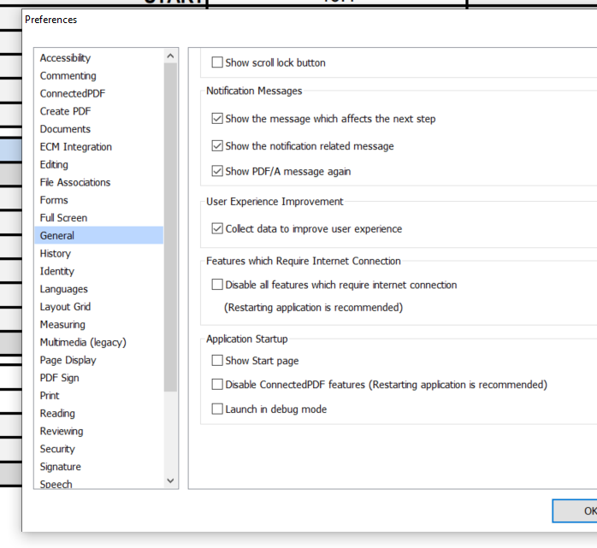

1. Go to excel file and set up the folder where you will keep all PDF files to be converted:

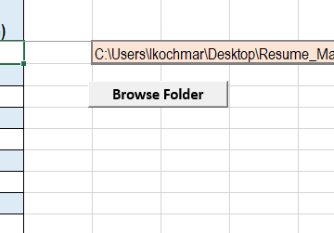

1. After PDF folder is set up, you can import files one by one by clicking on Import button

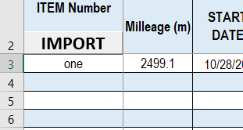

1. DONE!